∑={0,1,2,3,4,a,b,c,d,e}

Q={q0, q1, q2, q3, q4, q5, q6, q7, q8, q9, q10, q11, q12, q13,14}

q0=q0

A= {q7,q14}

|  |  |  |  |  |  |  |  |  |  |  |
| --- | --- | --- | --- | --- | --- | --- | --- | --- | --- | --- |
| Ϭ | 0 | 1 | 2 | 3 | 4 | a | b | c | d | e |
| q0 | {q1,q2} | {q1,q3} | {q1,q4} | {q1,q5} | {q1,q6} | {q8,q9} | {q8,q10} | {q8,q11} | {q8,q12} | {q8,q13} |
| q1 | {q1,q2} | {q1,q3} | {q1,q4} | {q1,q5} | {q1,q6} | X | X | X | X | X |
| q2 | q7 | X | X | X | X | X | X | X | X | X |
| q3 | X | q7 | X | X | X | X | X | X | X | X |
| q4 | X | X | q7 | X | X | X | X | X | X | X |
| q5 | X | X | X | q7 | X | X | X | X | X | X |
| q6 | X | X | X | X | q7 | X | X | X | X | X |
| q7 | q7 | q7 | q7 | q7 | q7 | X | X | X | X | X |
| q8 | X | X | X | X | X | {q8,q9} | {q8,q10} | {q8,q11} | {q8,q12} | {q8,q13} |
| q9 | X | X | X | X | X | q14 | X | X | X | X |
| q10 | X | X | X | X | X | X | q14 | X | X | X |
| q11 | X | X | X | X | X | X | X | q14 | X | X |
| q12 | X | X | X | X | X | X | X | X | q14 | X |
| q13 | X | X | X | X | X | X | X | X | X | q14 |
| q14 | X | X | X | X | X | q14 | q14 | q14 | q14 | q14 |

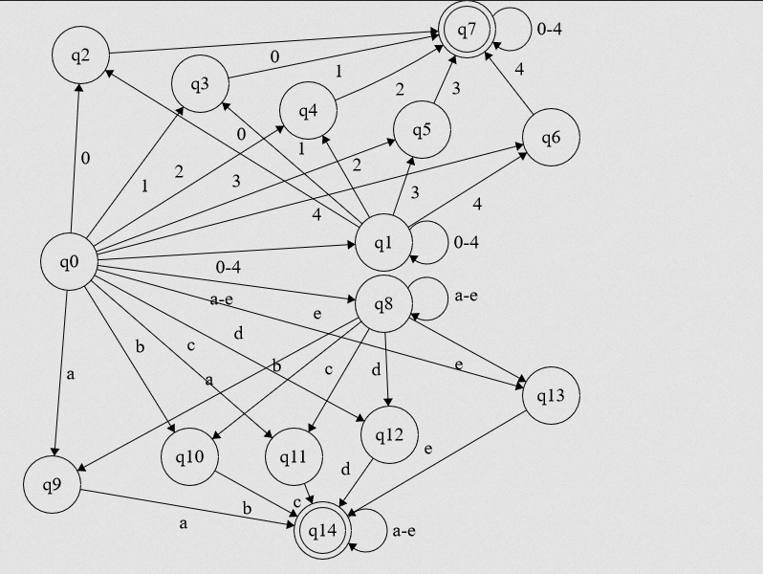δ = Q x ∑ 🡪